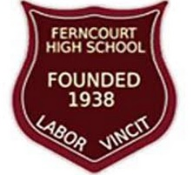

**MEMO**

**To:** Ms. Cross

**From**: Miss P. Clarke

CC: Ms. Howell

**Date:** June 2, 2022

**Re: Report of Prefect Fundraiser and Spending _______________________________**

During the period of March 21- 31, 2022, the prefect body sold raffle tickets with the intention of using the funds to help purchase their blazers, and giving back to the school through a project. Below is a breakdown of the results.

***TICKETS SOLD.***

Over the period, the students were able to sell ***Two Hundred Sixty Eight*** (268) tickets at a cost of ***One Hundred Fifty Dollars*** ($150) each. This gave them a total of ***Forty Thousand Two Hundred Dollars*** ($ 40, 200).

**EXPENDITURE**

For the prizes, we were successful in getting donation for two of the four prizes given to the students (the first and second placed prizes were donated). As a result, only two prizes were purchased from the funds through ticket sales at a cost of **Six Thousand Dollars ($ 6000).**

Regarding the project, we ‘refurbish’ the teachers’ restroom by the auditorium (paint, toilet bowl cover, potted plant) at a cost of **Five Thousand Dollars ($8000).** Again, donations were received which offset some of the cost (we received a paint, rollers, some cleaning products).

***BREAKDOWN OF EXPENDITURE***

* Third place prize (Ferncourt Branded Sweater) $3000.00
* Fourth place prize (Gift Basket) $3000.00
* Additional cleaning products $1000.00
* Lunch for the students on work day $2000.00
* Toilet seat $2000.00
* Miscellaneous (Extra Shammy) $ 200.00

**TOTAL** - $11 200.00

***CONCLUSION***

After expenditure, we have Twenty Nine Thousand Dollars (29 000.00). The prefects have decided to lodge this in their account at the school earmarked to assist the grade 10 prefects in getting blazers for the school year 2022-2023. This was turned over to the bursar. A copy of the receipt is at attached below. Receipts of purchases were also shown to the Culture Agent Ms. Cross on June 3, 2022. She advised they be stored in my draw for future reference.

***PHOTO HIGHLIGHTS***

***RAFFLE DRAW***

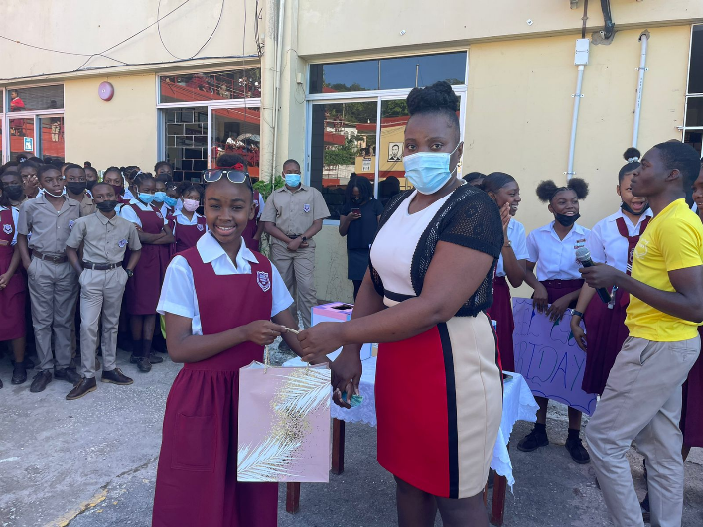

***Staff Advisor – Ms. Patricia Clarke with the first place winner***

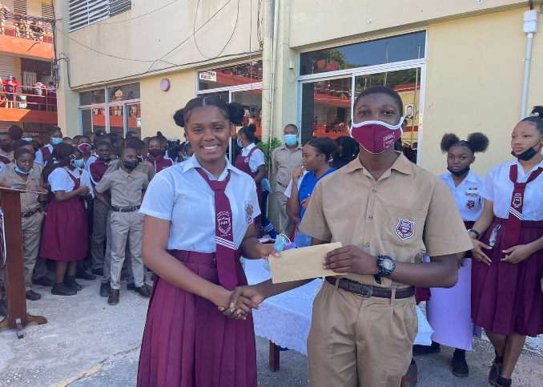

Ms. Abigail Morris with the second place winner

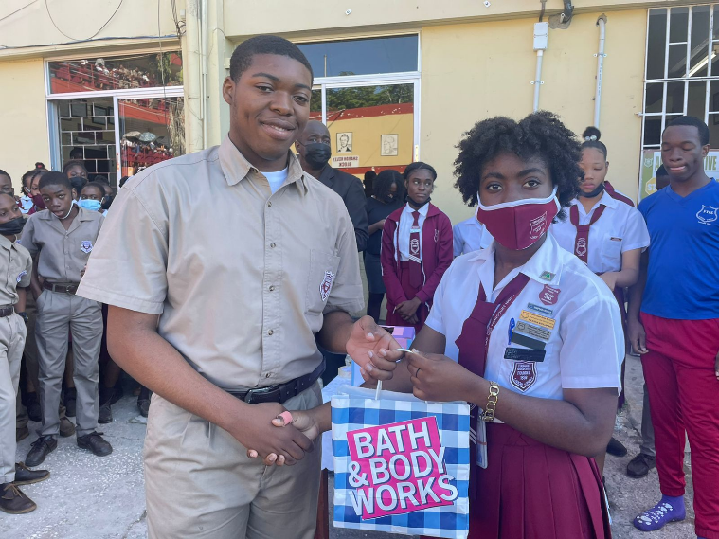

Head Girl – Ms. Yulanda Williamson with the third place winner

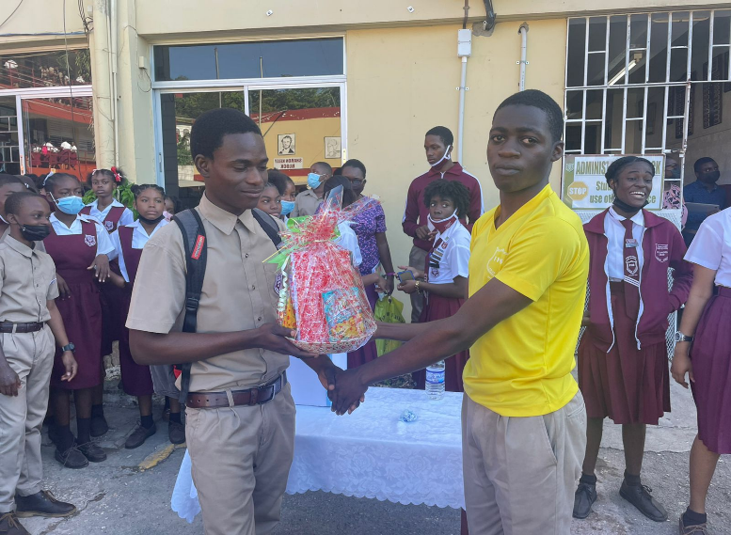

Head Boy – Mr. Ishmael Symthe with the fourth place winner

**Highlights of Students Giving Back by Painting one of the Staff Restrooms**

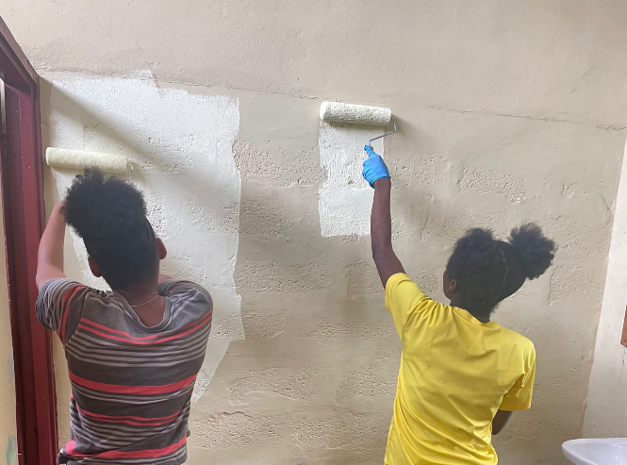

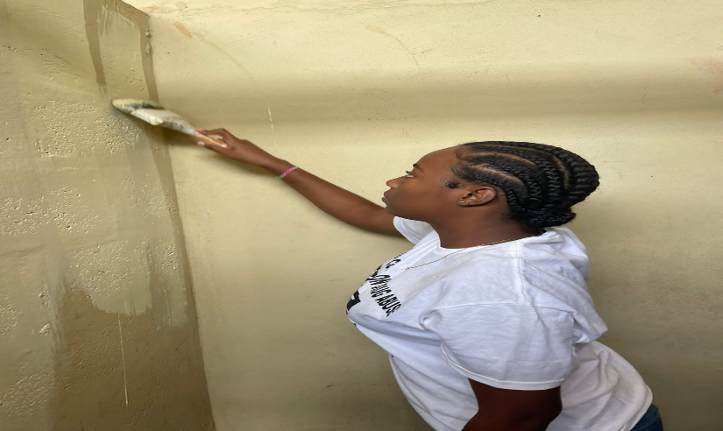

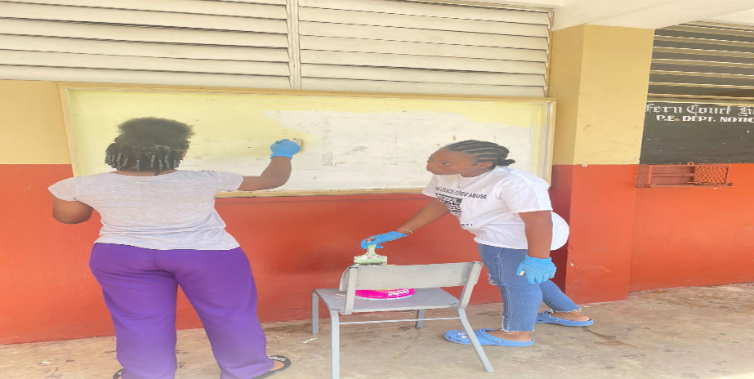

FINISH RESTROOM

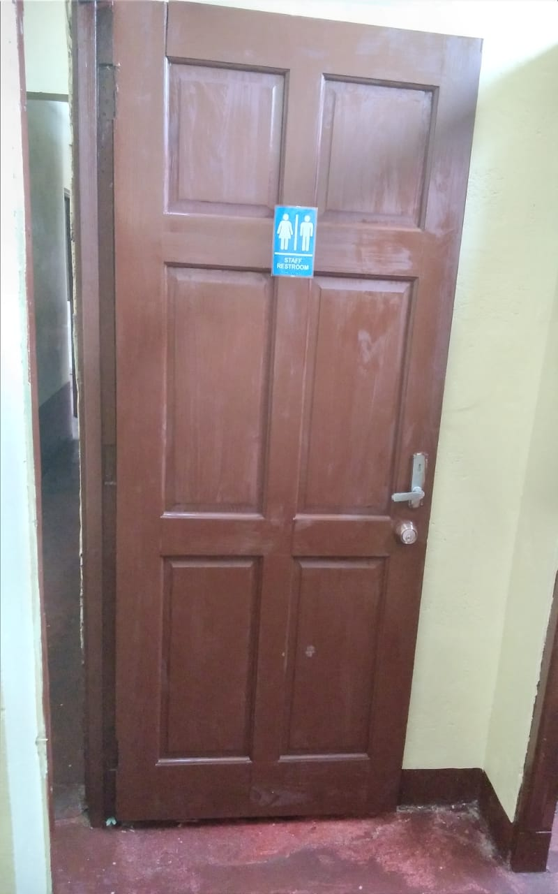

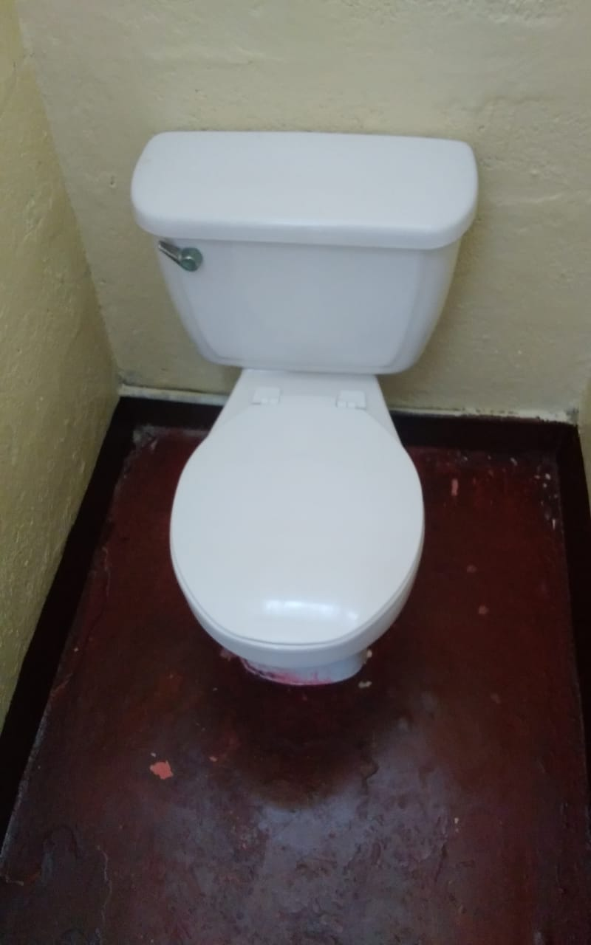

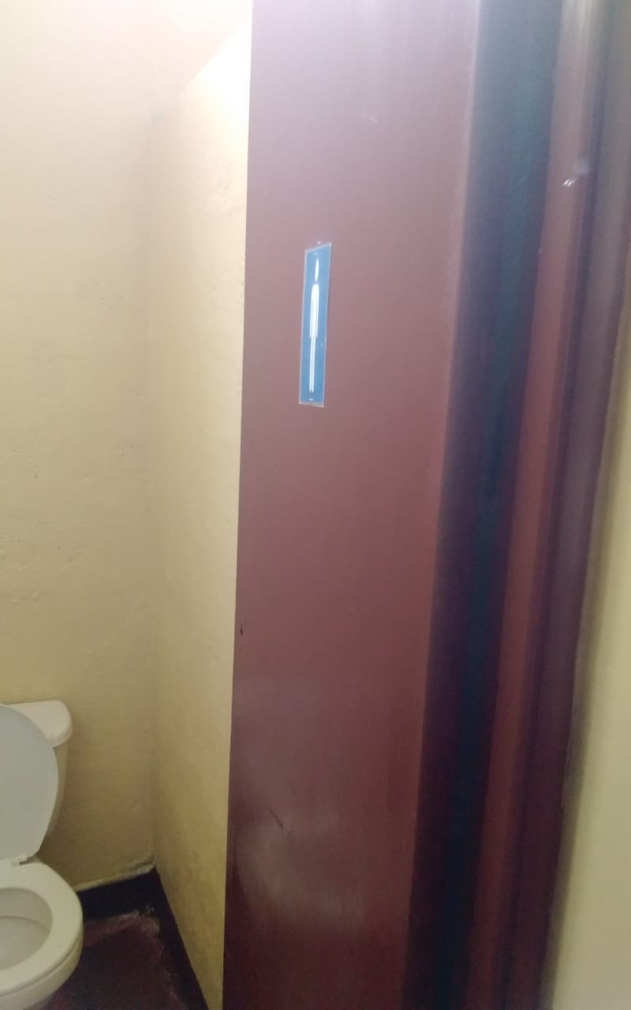

***ADDENDUM***

***Receipt of the rest of the funds paid over to the Bursar.***

